Om Pawar - 86092300006

Roll No - A006

Cloud Computing Practical

Practical 1 - Infrastructure as a service using AWS

# Writeup:-

* **Cloud Computing architecture**

Cloud computing architecture comprises the following key components:

* 1. Front End:
     + User Interface (UI)
     + Client (device)
  2. Back End:
     + Servers
     + Storage
     + Virtualization
     + Networking
  3. Middleware:
     + APIs
     + Runtime
  4. Cloud Services:
     + Infrastructure as a Service (IaaS)
     + Platform as a Service (PaaS)
     + Software as a Service (SaaS)
  5. Deployment Models:
     + Public Cloud
     + Private Cloud
     + Hybrid Cloud

# IAAS

Infrastructure as a Service (IaaS) is a cloud computing model that provides virtualized computing resources over the internet. In an IaaS environment, users can rent virtual machines, storage, and networking components on a pay-as-you- go basis. This eliminates the need for organizations to invest in and maintain physical hardware, as they can scale their infrastructure up or down based on demand. IaaS offers flexibility, allowing users to deploy and manage their own operating systems, applications, and development frameworks. This model is particularly beneficial for businesses with dynamic or fluctuating workloads, as it provides a cost-effective and scalable solution without the burden of managing and maintaining physical infrastructure. Popular IaaS providers include Amazon Web Services (AWS), Microsoft Azure, and Google Cloud Platform (GCP).

# AWS

Amazon Web Services (AWS) is a comprehensive and widely used cloud computing platform provided by Amazon. Launched in 2006, AWS offers a vast array of computing services, including computing power, storage options, and databases, delivered over the internet. AWS allows businesses and individuals to access scalable and cost-effective cloud solutions without the need for significant upfront investments in physical infrastructure. It provides a range of services, from Infrastructure as a Service (IaaS) with offerings like Amazon EC2 virtual servers, to Platform as a Service (PaaS) with tools like AWS Elastic Beanstalk for application deployment and management. AWS has a global presence with data centers in various regions, ensuring low-latency access to services. Its flexibility, reliability, and extensive service catalog make AWS a go-to choice for organizations of all sizes, from startups to large enterprises, seeking to leverage cloud computing for their diverse computing needs.

# AWS services

**Amazon Web Services (AWS) offers a wide range of cloud computing services, covering computing power, storage, databases, machine learning, analytics, networking, security, and more. Here's an overview of some key AWS services:**

1. Compute Services:
   * Amazon EC2 (Elastic Compute Cloud): Provides resizable compute capacity in the cloud, allowing users to run virtual servers for various applications.
   * AWS Lambda: Enables serverless computing, where you can run code without provisioning or managing servers.
2. Storage Services:
   * Amazon S3 (Simple Storage Service): Offers scalable object storage for data backup, archiving, and content delivery.
   * Amazon EBS (Elastic Block Store): Provides block-level storage volumes for use with EC2 instances.
3. Database Services:
   * Amazon RDS (Relational Database Service): Manages relational databases such as MySQL, PostgreSQL, and Oracle.
   * Amazon DynamoDB: A fully managed NoSQL database service for applications requiring low-latency and high-performance data access.
4. Networking:
   * Amazon VPC (Virtual Private Cloud): Enables users to launch Amazon Web Services resources into a virtual network.
   * Amazon Route 53: A scalable domain name system (DNS) web service.
5. Machine Learning and AI:
   * Amazon SageMaker: A fully managed service that enables developers to build, train, and deploy machine learning models.
   * Amazon Comprehend: A natural language processing service that extracts insights and relationships from text.
6. Analytics:
   * Amazon Redshift: A fully managed data warehouse service for running complex queries on large datasets.
   * Amazon EMR (Elastic MapReduce): A cloud-based big data platform for processing vast amounts of data quickly.
7. Management and Monitoring:
   * Amazon CloudWatch: Monitors AWS resources and applications, collecting and tracking metrics.
   * AWS CloudTrail: Records AWS API calls for account activity tracking and security analysis.
8. Security:
   * AWS Identity and Access Management (IAM): Manages access to AWS services securely.
   * AWS Key Management Service (KMS): Creates and controls encryption keys used to encrypt data.
9. Serverless Computing:
   * AWS Step Functions: Coordinates the components of distributed applications using visual workflows.
   * Amazon API Gateway: Creates, publishes, and manages APIs.
10. Internet of Things (IoT):

- AWS IoT Core: Connects devices to the cloud and enables secure communication between them.

# EC2

Amazon Elastic Compute Cloud (Amazon EC2) is a central component of Amazon Web Services (AWS), providing scalable and resizable compute capacity in the cloud. With EC2, users can easily launch virtual servers, known as instances, to run applications, host websites, and perform various computing tasks. Users have flexibility in choosing the instance type, operating system, storage, and network configurations, allowing for tailored computing environments. EC2 instances can be provisioned and scaled up or down based on demand, providing cost efficiency by paying only for the resources used. This on-demand nature makes EC2 suitable for a wide range of applications, from simple web hosting to complex, high-performance computing tasks. Additionally, EC2 instances can be

integrated with other AWS services, offering a comprehensive and customizable cloud computing solution for businesses and developers.

# Implement the windows machine using AWS ec2.

**STEPS:**

Step 1: Sign into your AWS account Step 2: Select All Services, Select EC2

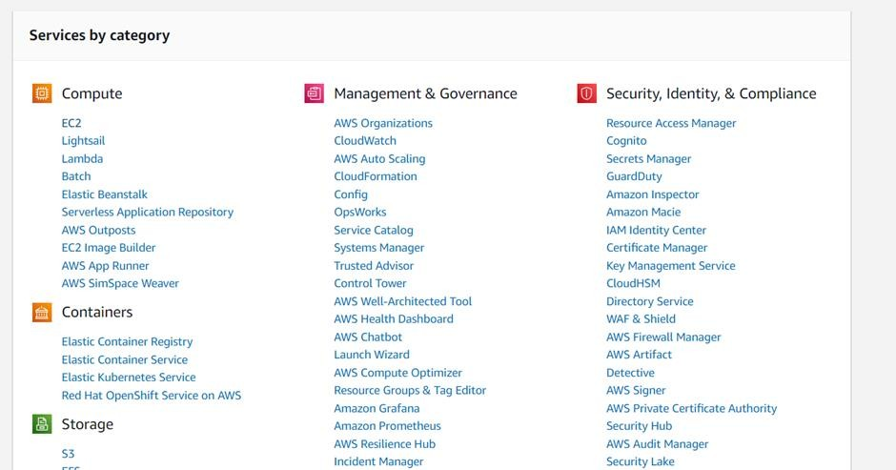

Step 3: Launch Instance, create key value pair, pem and save Step 4: Select Windows and launch the instance

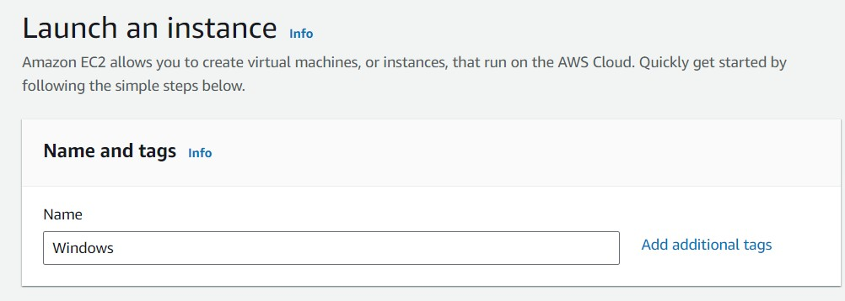

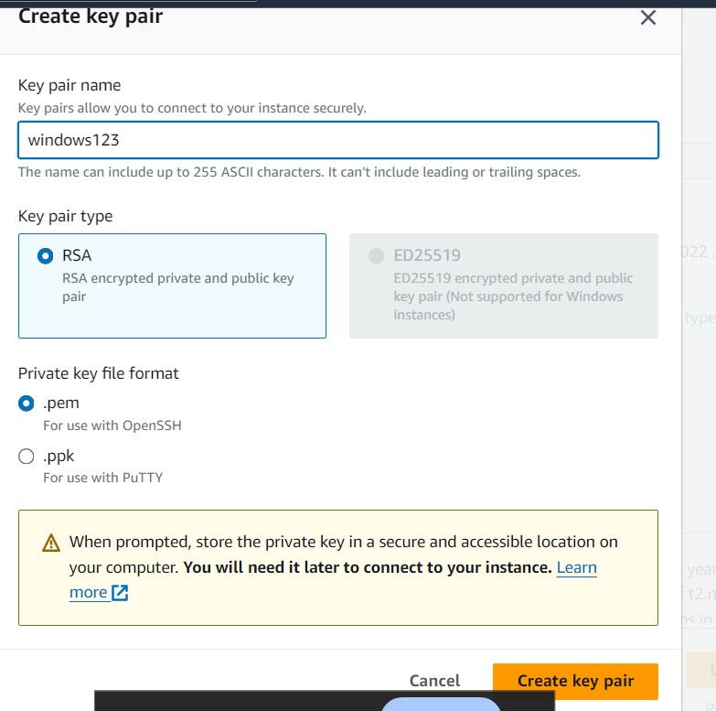

Step 5: Go to instances and initialize and then start running

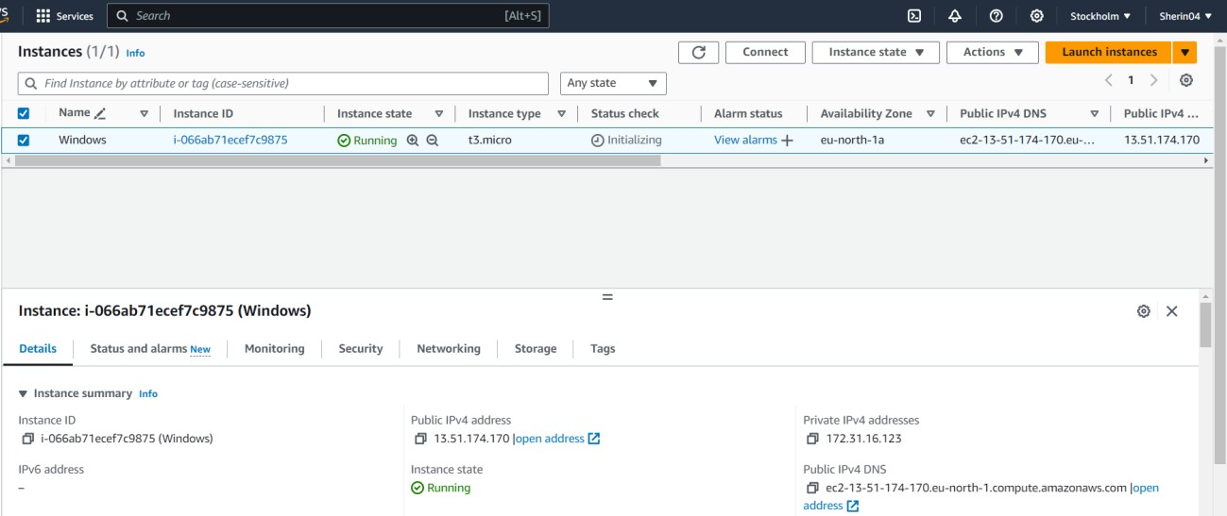

Step 6: Select the instance, click on connect for connecting the RDP client

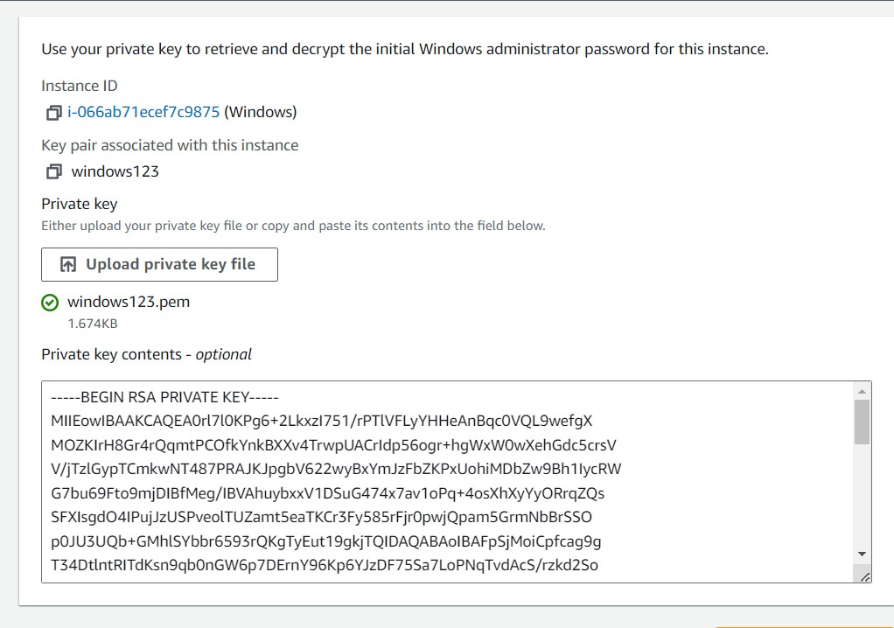

Step 7: Decrypt the password. Copy the password.

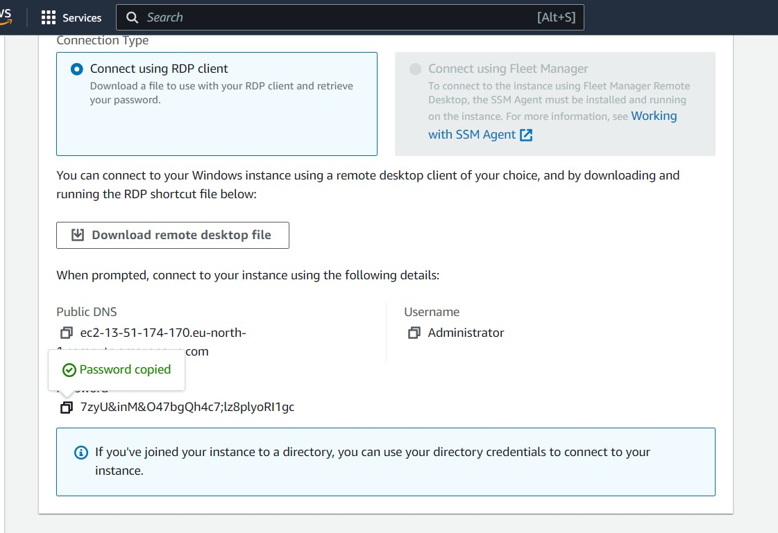

Step 8: Open remote desktop connection

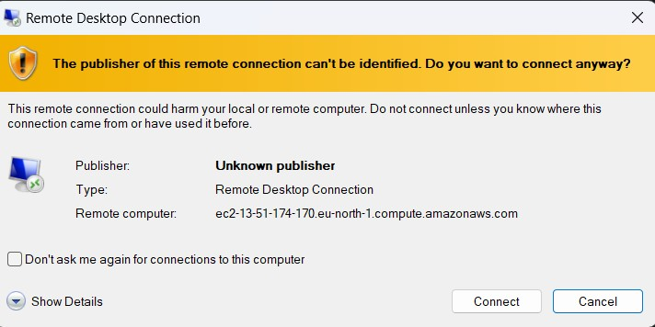

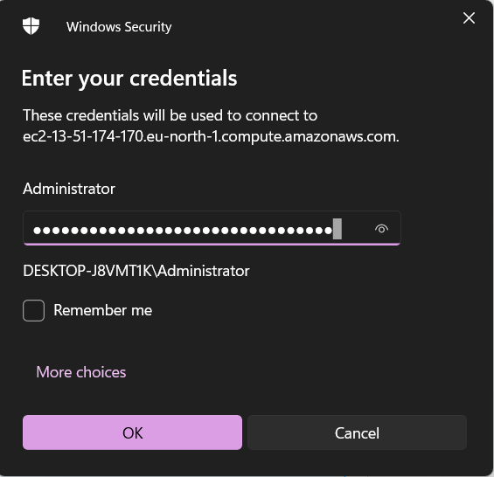

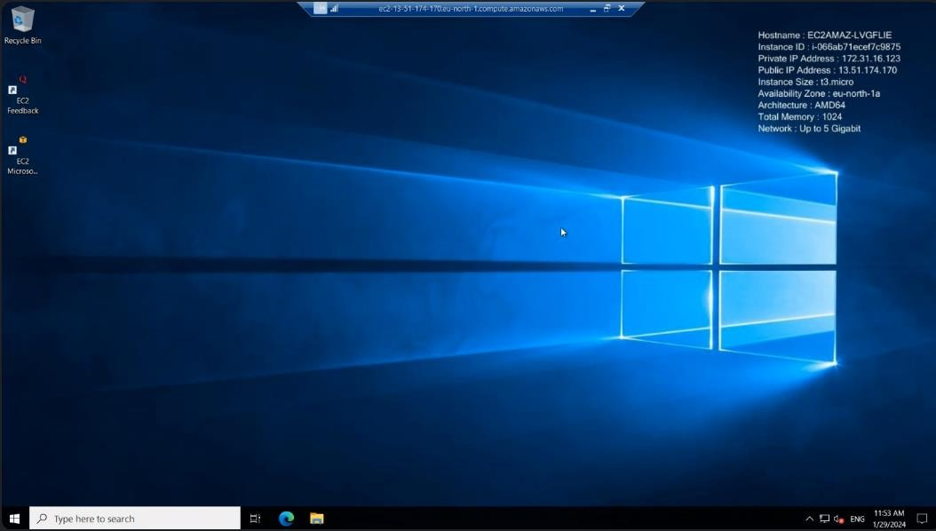

Step 9: Close RDP and go back to instances Step 10: Terminate the instance

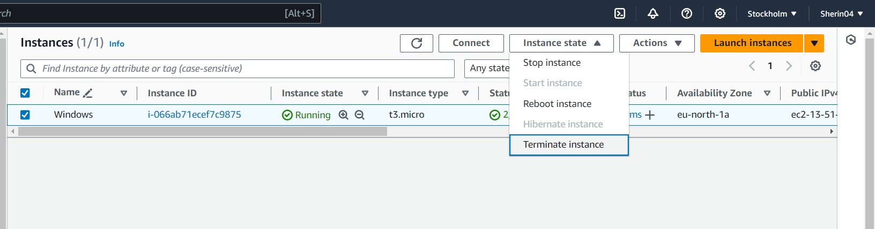

# Implement Ubuntu machine using AWS ec2 and execute the Linux commands.

* + Disk information in human readable format
  + Create a folder with your name
  + Create a file with your cityname and add your address in it
  + Display the created file
  + Copy the contents of the created file in other file and print it
  + Install firefox/python 3

STEPS:

Step 1: Launch a new instance for Linux

Step 2: Write a new web server name and select Ubuntu server

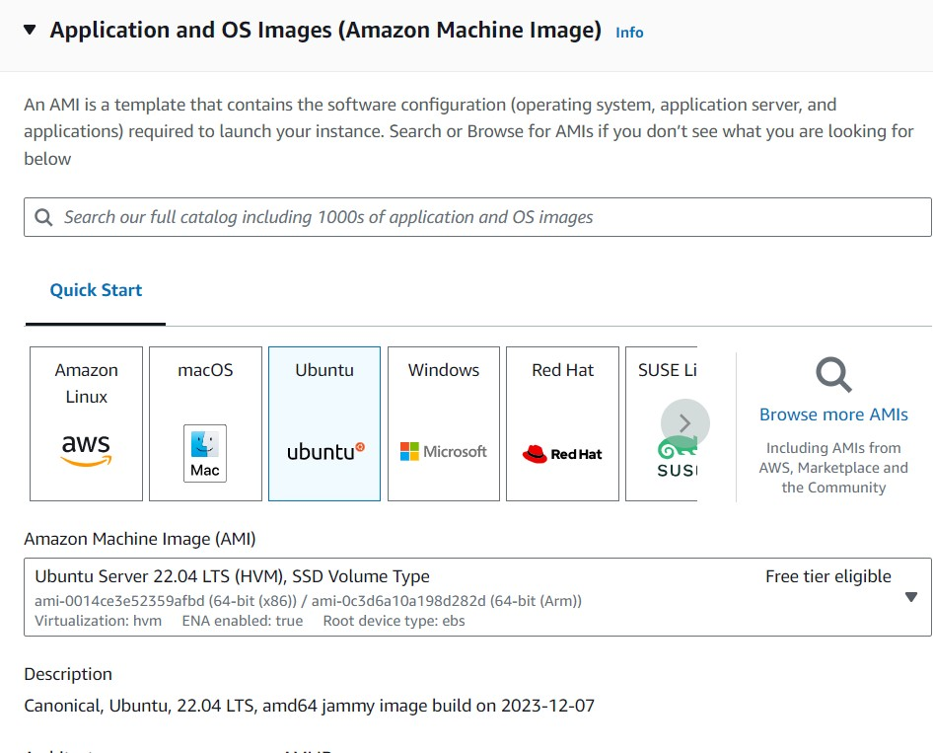

Step 3: Create a new key value pair and select ppk

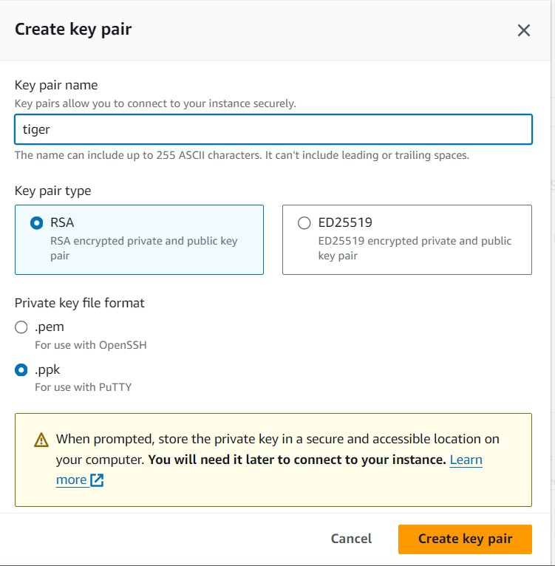

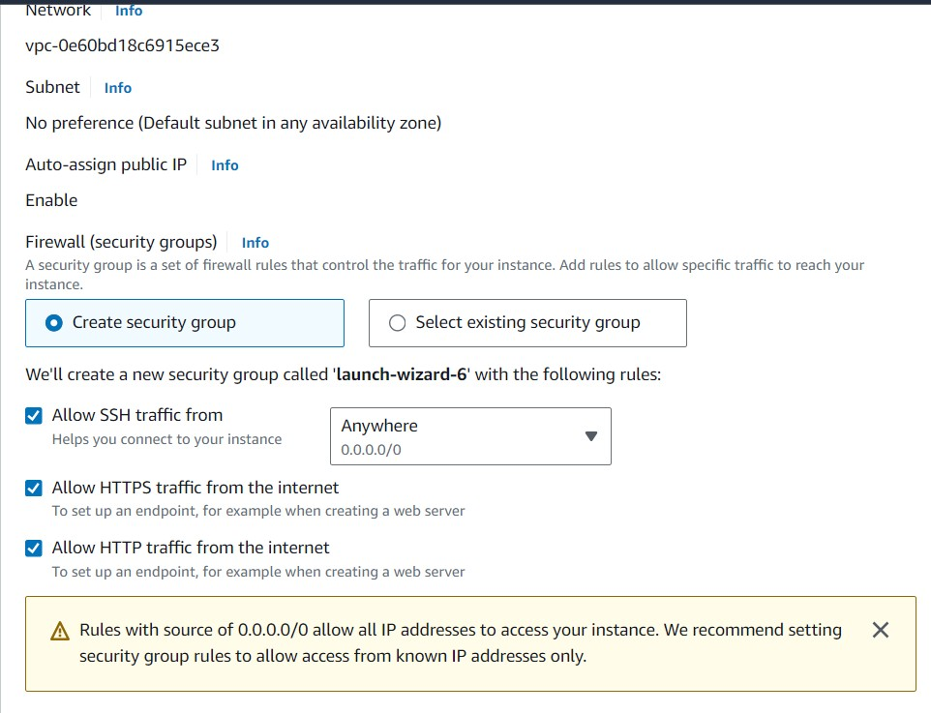

Step 4: Download putty.exe file from Google

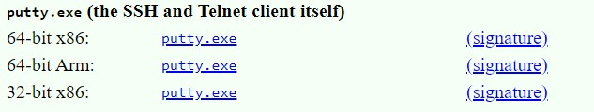

Step 5: Launch the instance

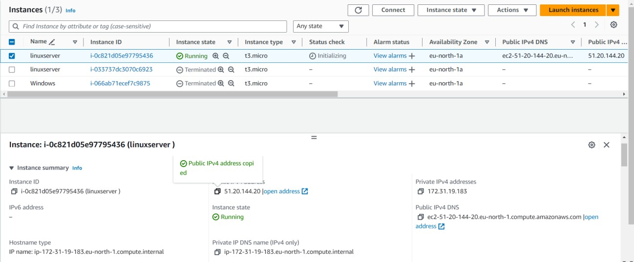Step 6: Select and copy public IPV4 address

Step 5: Go to putty and paste the IP address

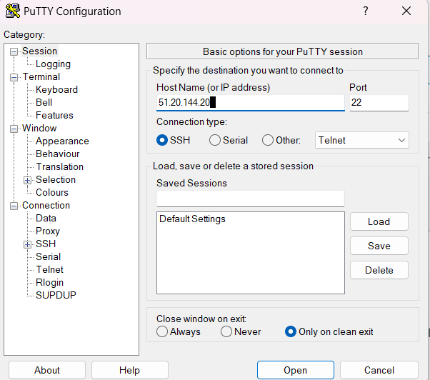

Step 6: Go to category → SSH → auth → credentials → select the ppk file

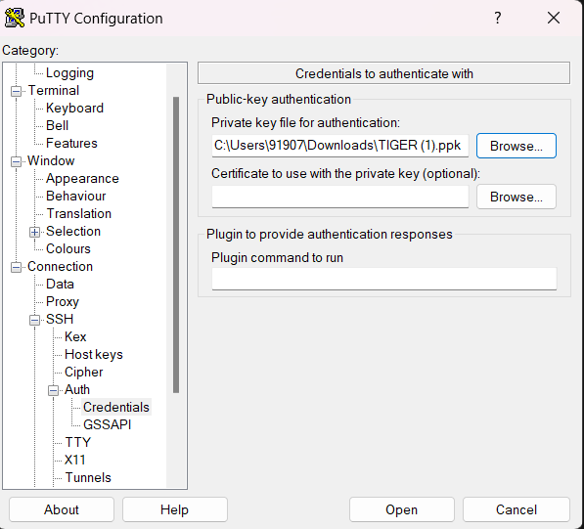

Step 7: Putty will launch Step 8: Login as ubuntu

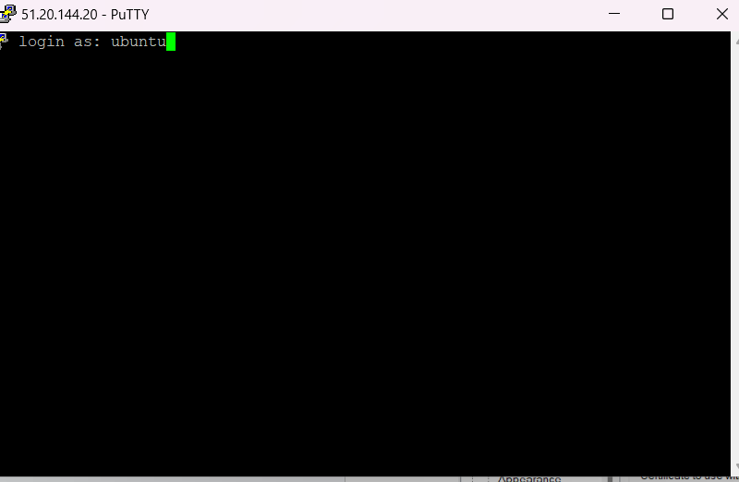

Step 9: Install python

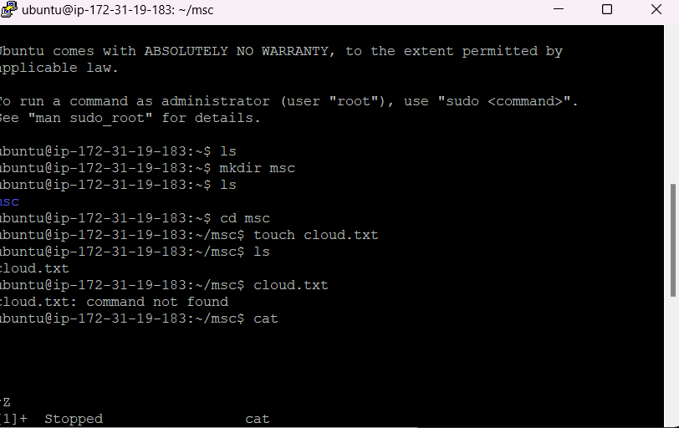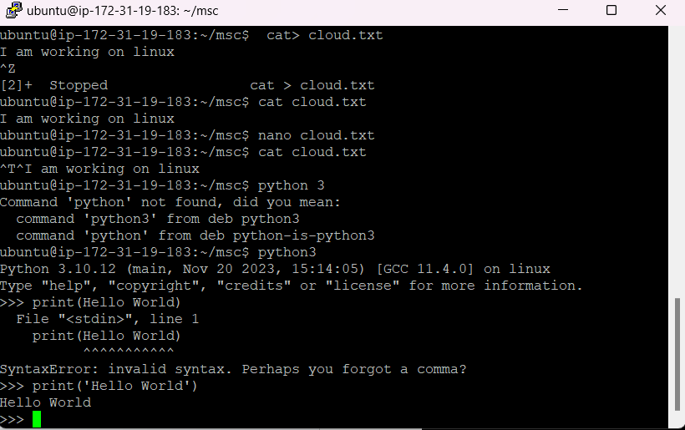

Step 10: Install Firefox

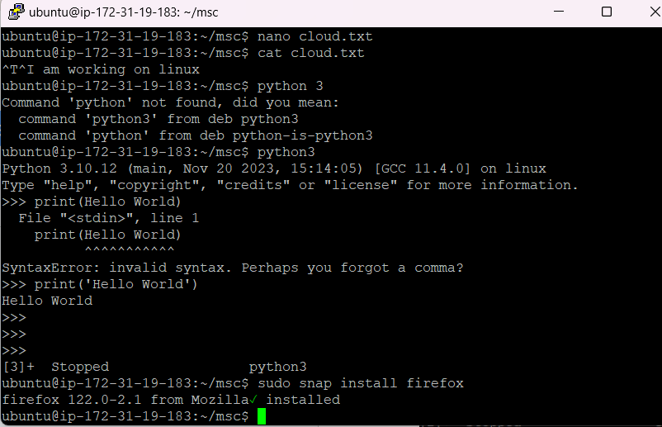

Our setup is Ready !!